Disk management (LVM)

LVM Basics
LVM (Logical Volume Manager) provides a more flexible approach to managing disk storage compared to traditional partitioning. It allows dynamic resizing and management of storage components.
Hierarchy:
Hard disks → Partitions → Physical Volume (PV) → Volume Group (VG) → Logical Volume (LV) → Filesystem → Mount point
- xfs: Can only extend (cannot reduce).
- ext4: Can extend and reduce.

Creating Physical Volumes (PV) and Volume Groups (VG)

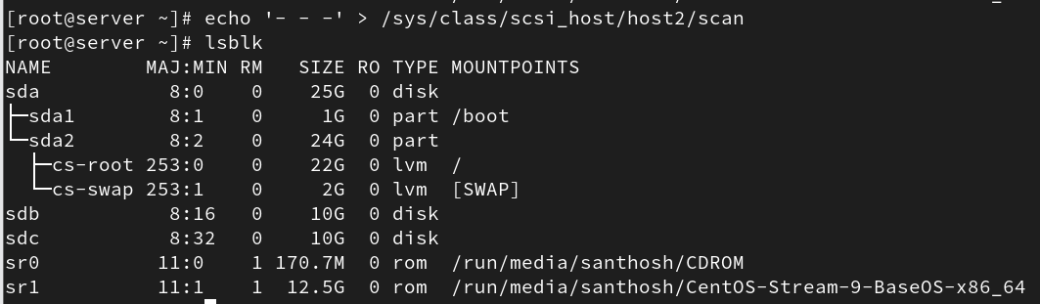
1. Convert a disk/partition into a Physical Volume:
# pvcreate /dev/sdb /dev/sdc
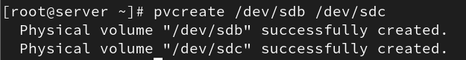
2. Create a Volume Group (VG):
# vgcreate vg1 /dev/sdb

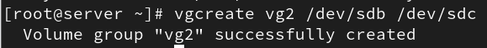
3. Extend an existing Volume Group:
# vgextend vg1 /dev/sdc

4. Display Commands:
# pvs → Show physical volumes
# pvscan → Scan for PVs
# pvdisplay → Detailed PV info
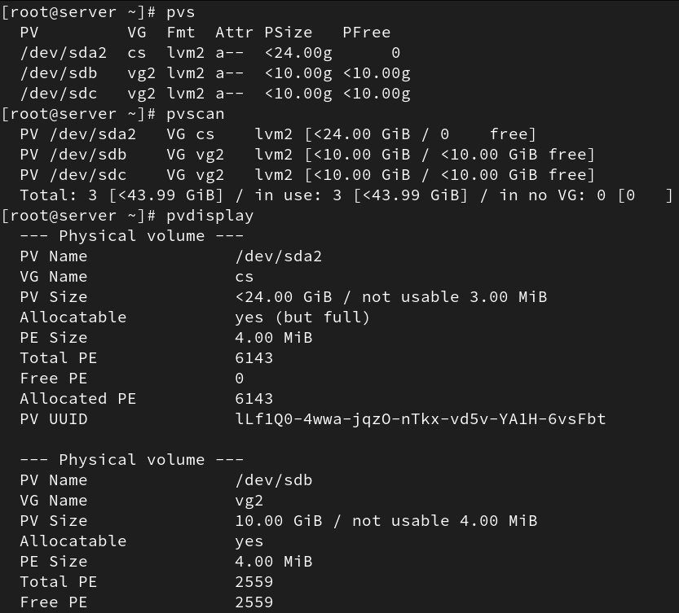
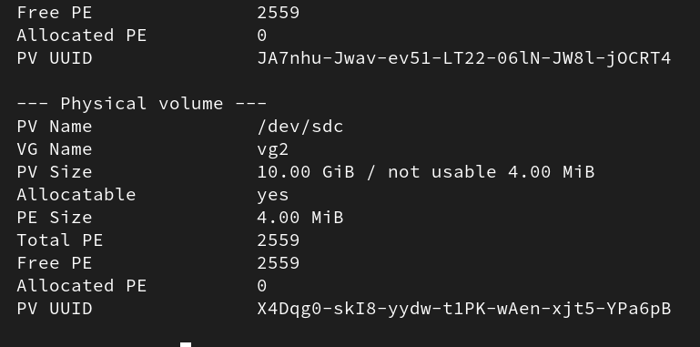
# vgs → Show volume groups
# vgscan → Scan for VGs
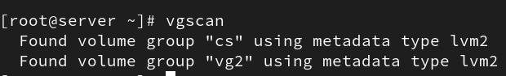
# vgdisplay → Detailed VG info
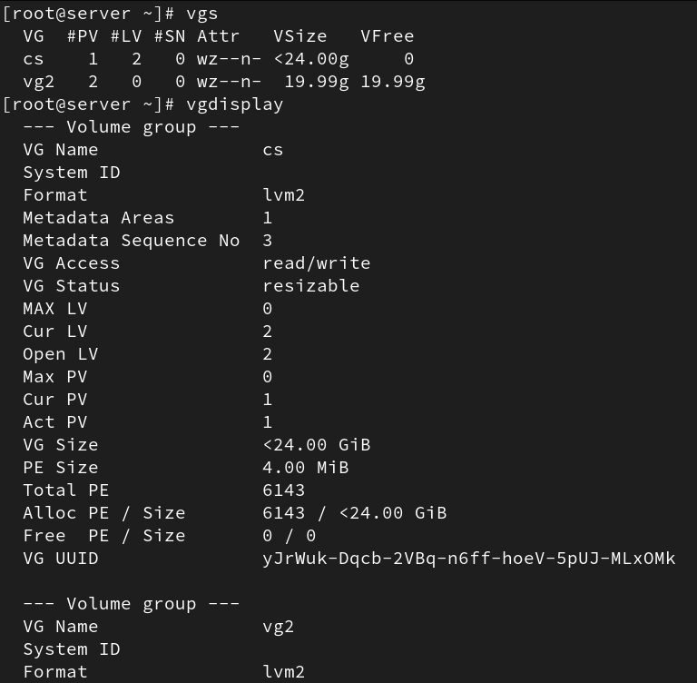
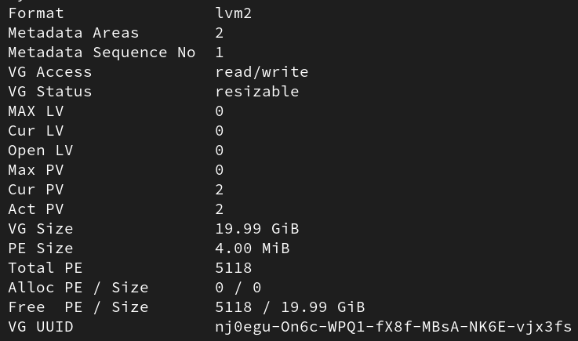

Creating Logical Volumes (LV)
1. Create a Logical Volume:
# lvcreate -L +5G -n lv1 vg1
# lvcreate --size 5G --name lv2 vg1
# lvcreate -l +25G -n lv3 vg1
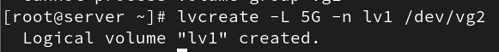
2. Display LV info:
# lvs
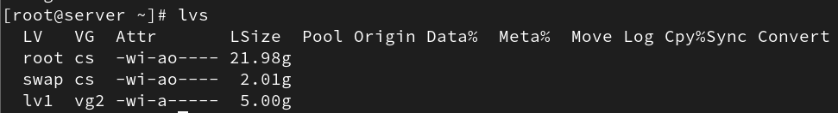

Creating Filesystems and Mounting
After creating an LV, format it with a filesystem and mount it.
1. Create filesystem:
# mkfs.xfs /dev/vg1/lv1
# mkfs -t ext4 /dev/vg1/lv2
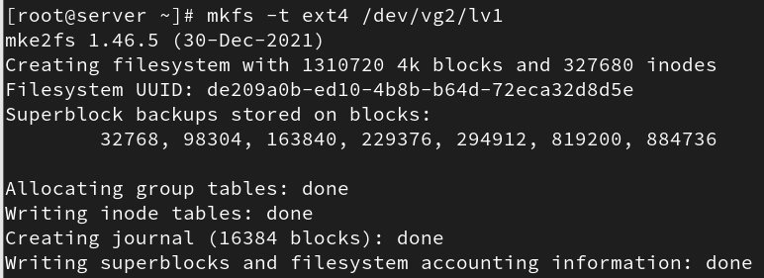
2. Create mount points and mount:
# mkdir /lv1
# mkdir /lv2
# mount /dev/vg1/lv1 /lv1
# mount /dev/vg1/lv2 /lv2
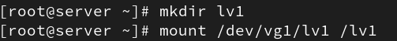
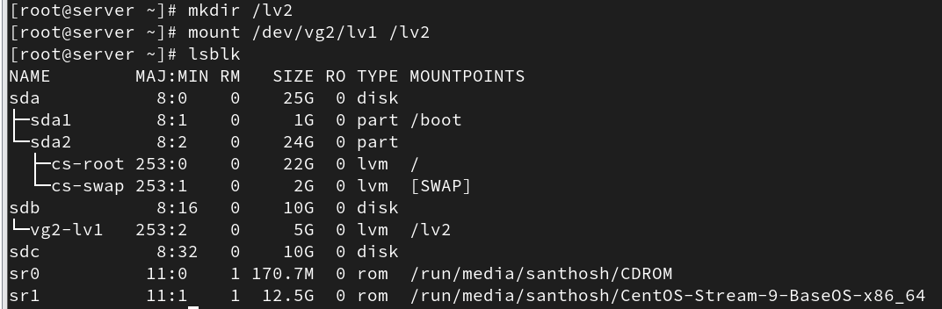

Extending and Reducing Logical Volumes
1. Extend a Logical Volume:
# lvextend -L +2G /dev/vg1/lv2
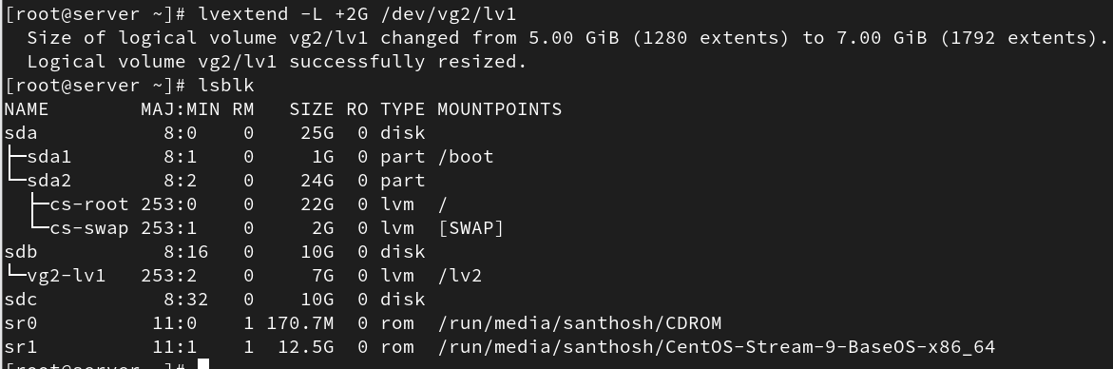
2. Reduce a Logical Volume (only for ext4):
a. Unmount first:
# umount /dev/vg1/lv1
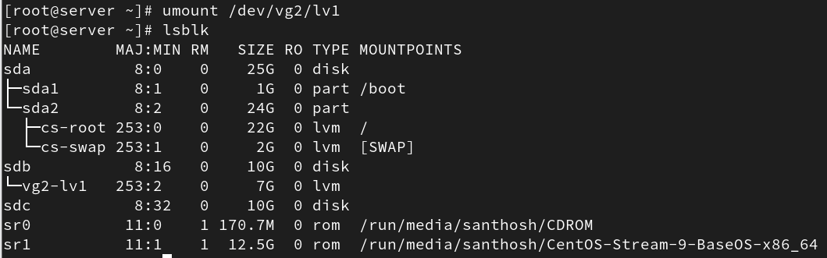
b. Check filesystem errors:
# e2fsck -f /dev/vg1/lv1
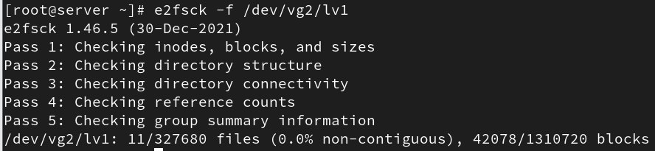
c. Resize filesystem:
# resize2fs /dev/vg1/lv1
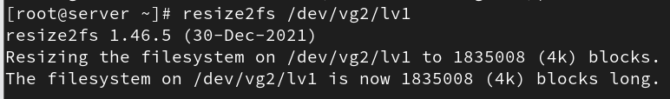
d. Reduce LV size:
# lvreduce -L -3G /dev/vg1/lv1
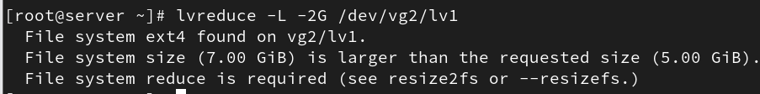
3. Resize filesystem after extension:
# resize2fs /dev/vg1/lv1 (ext4)
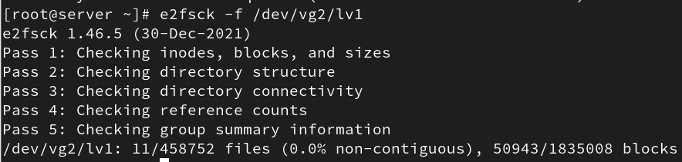
# xfs_growfs /dev/vg1/lv1 (xfs)

Post-Reduction and Verification
After resizing or reducing:
- Run filesystem check (optional for xfs, mandatory for ext4).
# e2fsck -f /dev/vg1/lv1
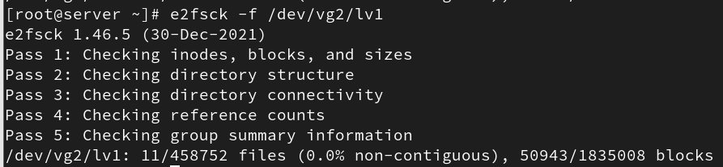
- Mount again:
# mount /dev/vg1/lv1
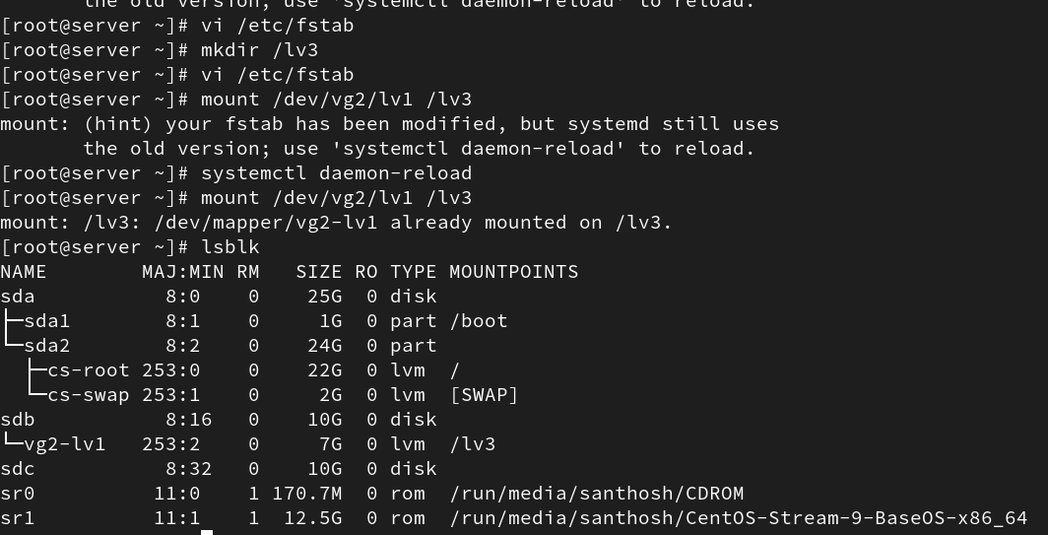

- Verify:
# lvs
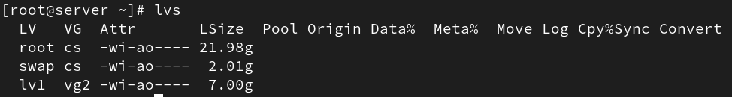

Removing LVM Components
To remove LVM components:
1. Remove mount entries from /etc/fstab.
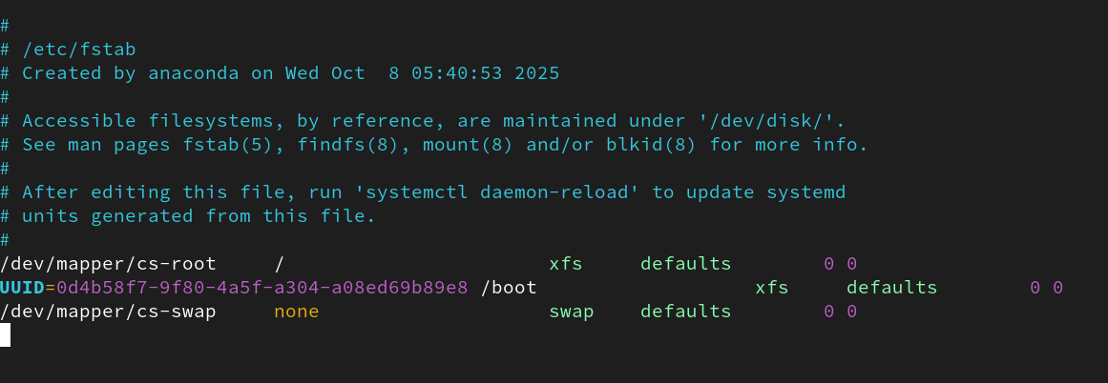

2. Unmount:
# umount /lv1 /lv2
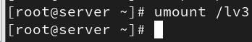
3. Remove logical volumes:
# lvremove /dev/vg1/lv1

4. Remove volume group:
# vgremove vg1
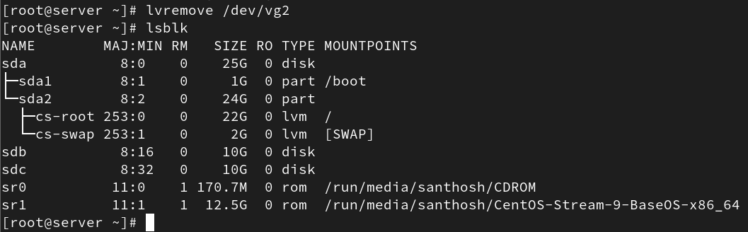
5. Remove physical volume:
# pvremove /dev/sdb
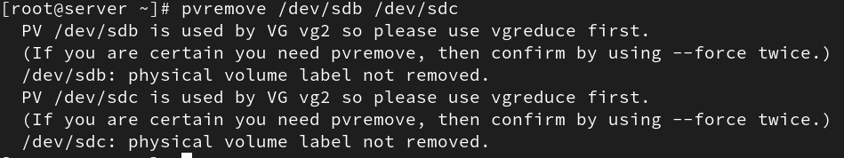
Useful command:
# lsblk → Display block devices and hierarchy
